- Carbon Markets
- Gender equality
- Youth leadership
- Sustainable development

National Position Paper Summary
This National Position Paper presents Bangladesh’s strategic vision and priorities for COP30, focusing on equitable climate action, enhanced finance, and strengthened global cooperation under the Paris Agreement. It emphasizes Bangladesh’s proactive approach in advancing adaptation, mitigation, and loss and damage responses while promoting sustainable development in line with national policies and international commitments.
Based on the ideas of climate justice, global accountability, and community-led action, the paper consolidates the collective demands of Bangladesh's Civil Society Organizations (CSOs). It demonstrates Bangladesh's dedication to making sure that global climate policies are equitable, inclusive, and responsive to the needs of vulnerable populations.
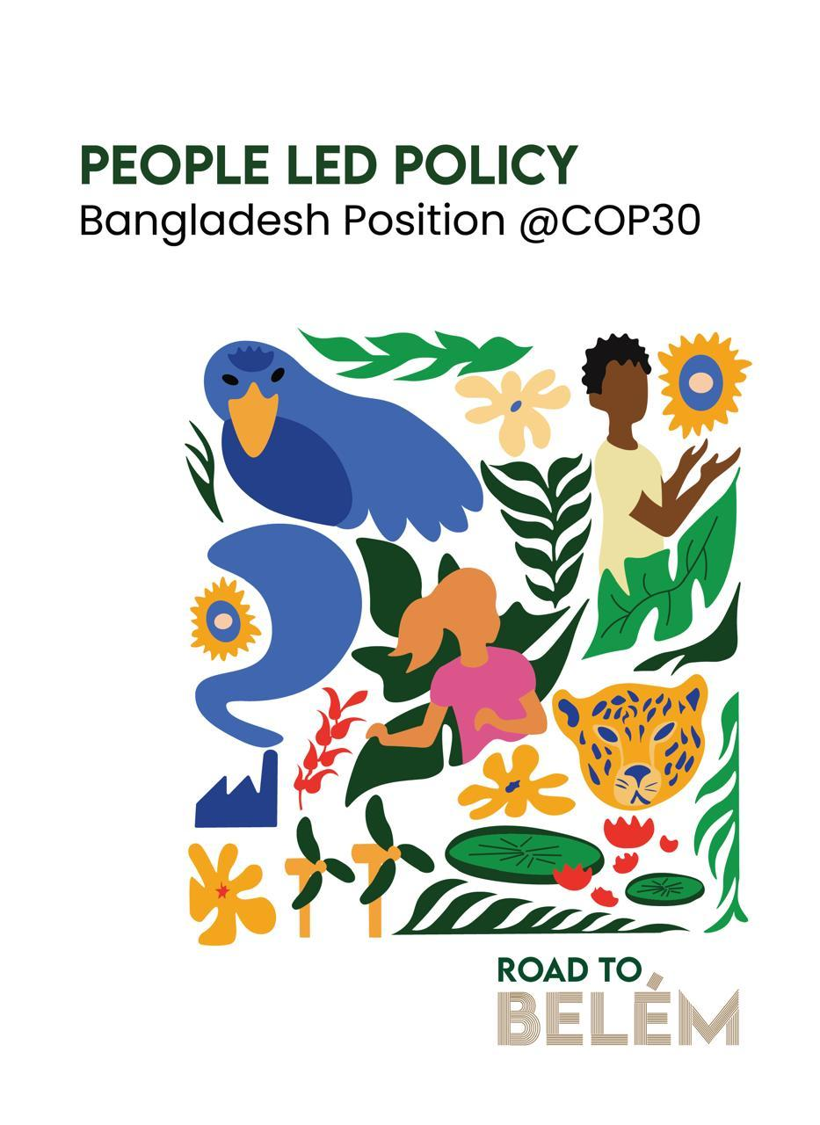
Acknowledging the potential of Article 6, Bangladesh seeks to improve cooperative carbon markets and non-market mechanisms mobilizing resources, promoting technology transfer, and enhancing institutional capacity. The country’s readiness is reflected in its established national frameworks, pilot projects in key sectors, and commitment to transparency and inclusiveness in implementation. Communities across Bangladesh expect COP30 to deliver tangible outcomes, including the operationalization of the Loss and Damage Fund, direct and easily accessible climate finance for local actors, recognition of non-economic losses, improved technology transfer, gender equality, and accountability from high-emission countries. These priorities reflect the nation’s call for justice, fairness, and inclusiveness in global climate governance.
The paper further emphasizes the importance of gender equality, youth leadership, and social inclusion in all climate decision-making processes. It calls high emission counties to show accountability by significantly stepping up their pledges to reduce emissions and by giving climate-vulnerable states fair assistance and compensation.
In the end, Bangladesh demands for collective global responsibility, simplified financial mechanisms, and stronger international support for vulnerable nations. Through active engagement at COP30, Bangladesh aims to strengthen its position as a leader among climate-vulnerable nations and help to create a just, transparent, and sustainable global climate framework.

